 Harmonize for Speech, Hearing & Language Clinic



Adult Speech-Language Intake Form

DO YOU NEED HELP FILLING OUT THIS FORM? □YES □ NO
Today’s date: _______________________________________________
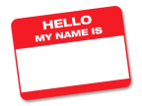  Last Name: | First Name:
  Address: | City: Postal Code:
  Telephone #: ( ) ____ - ____________ |   Email Address:
Date of Birth: |   Gender:  □Female □Male
    Emergency Contact Person: | Contact Person’s Phone #:  ( ) ____ - ____________
  Present/ Past Occupation: |   Highest Level of Education:
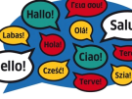  First Language: | Other Languages Spoken:

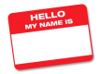

PHYSICIAN INFORMATION
Family Physician’s name: __________________________ Phone: ( ) ____ - _________

Other physicians involved in your care: ____________________________________________________________________________________________
MEDICAL HISTORY (Related to the Communication Difficulty)
Date of occurrence for difficulty / injury/ illness: ________________________________________________
Cause of Difficulty/ Injury/ Illness:
  Accident | 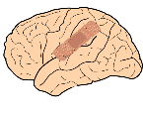  Brain Injury |   Stroke |   Disease  Type:  _________________ | Other:  __________________  __________________

Please list any medications that you are currently taking:


ALLERGIES
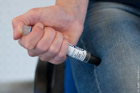

Do you have any allergies? □YES □ NO
If yes, please list them. Do you use an Epi Pen? □YES □ NO

Do you have any other medical concerns? (Example: epilepsy, seizures, paralysis, migraines)

COMMUNICATION DIFFICULTIES
Communication Difficulty |   YES | NO | SOMETIMES

Friends & family can’t understand my speech
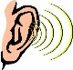
Difficulty hearing

Difficulty finding words

My speech is slow

My voice has changed

Stuttering

Difficulty getting my thoughts out


Swallowing difficulties
Memory or thinking
Other:
Have you had a speech-language assessment? □YES □ NO
If yes, where and when? _________________________________________________________
Have you had previous speech-language therapy? □YES □ NO
If yes, where and when? _________________________________________________________

Do you, or have you ever had, problems with feeding?
Swallowing |   Drooling | Chewing   | Coughing   | Choking  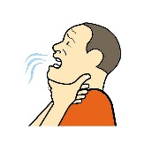 | Other:  ______________  ______________

SPEECH

How do you usually communicate?
□Gestures □Single words □Short phrases □Sentences □No problems
□Other: ______________________________________________________

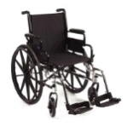
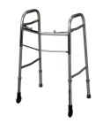
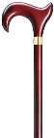
Please check any supportive aids that you use:

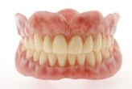
□Cane □Walker □Wheelchair
□Dentures □Eye glasses □Other _______________________________

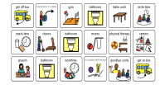
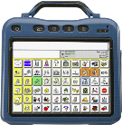
Please check any communication aids that you use:

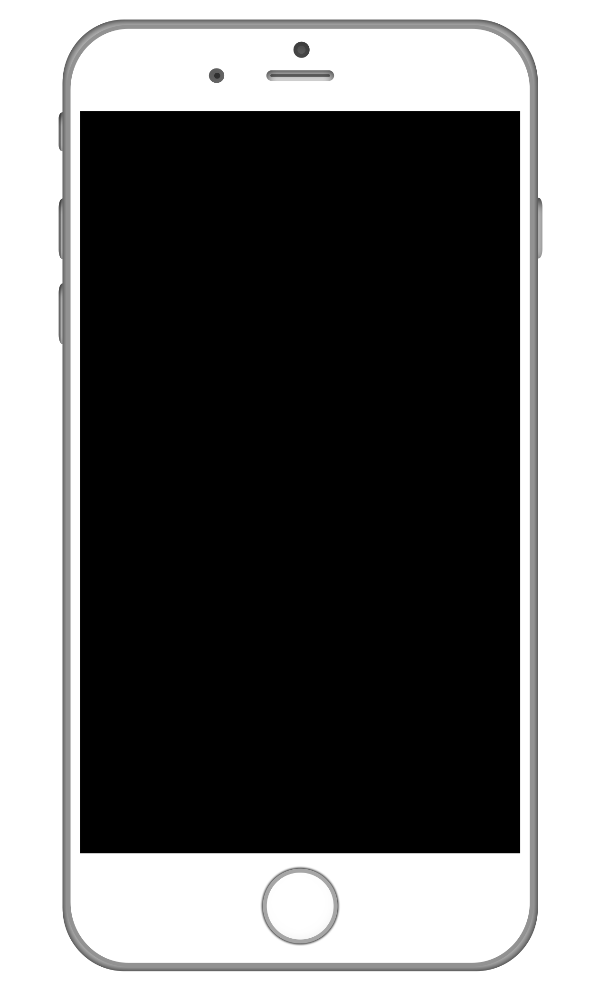

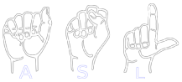
□Communication device □Alphabet/picture board □Sign language
□Paper and pen □ iPad □ Cell phone □Other __________________



Which hand do you use for writing?
Left Right

HEARING DIFFICULTIES
Do you have hearing difficulties: □YES □ NO
Have you ever had a hearing test? □Yes □ No
If yes, where and when? _________________________________________________________
If no, do you have any concerns about your hearing? □Yes □ No
Do you wear a hearing aid? □Yes □ No

Has your communication difficulty affected your social life? □Yes □ No
If yes, please explain: ____________________________________________________________________________________________
____________________________________________________________________________________________

What are your hobbies & interests? Are you involved in any group activities?

________________________________________________________________________________________________________________________________________________________________________________________

What are your preferences in reading material? __________________________________________
What are your preferences in TV/entertainment? __________________________________________

Have there been any changes in mood, personality, ability to care for self since the occurrence of your difficulty / injury/ illness?
____________________________________________________________________________________________
____________________________________________________________________________________________
Is there any additional information that would help us to better understand the nature of your communication difficulty?
________________________________________________________________________________________________________________________________________________________________________________________


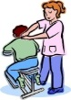
Please list any community supports/referrals/professional agencies involved in your care. (Example: Brain Injury Services, CCAC, Occupational Therapist, Physiotherapist, Social Worker, Registered Dietician, Neurologist.)
________________________________________________________________________________________________________________________________________________________________________________________
____________________________________________________________________________________________

Thank You!
We thank you for your time, and the care with which you filled out this form. This intake form will be reviewed by our clinic Speech-Language Pathologist (SLP) and Communicative Disorders Assistant (CDA) students and will be a reference for them in planning your therapy services at our clinic.
While we strive to provide all clients with the therapy services that they desire, we would like you to keep two things in mind:
- All clients seeking therapy services at this clinic must have had a formal speech-language assessment completed prior to starting therapy in this clinic.
- This is a teaching clinic and there will be times during therapy sessions where our CDA students will be receiving direction from our clinic SLP.
We appreciate your patronage, and look forward to helping you and your loved ones.
The Faculty SLP Clinician(s), CDA students, and Staff
of the
Harmonize for Speech, Hearing & Language Clinic

